**Bug Bounty Hunting: Get Paid to Break Stuff (Legally)**

Meta: Want to poke holes in billion-dollar tech, find the bugs developers tried to bury, and maybe get paid in T-shirts, swag, or $30,000? Welcome to bug bounty hunting.



Photo by [Boitumelo](https://unsplash.com/@writecodenow?utm_source=medium&utm_medium=referral) on [Unsplash](https://unsplash.com/?utm_source=medium&utm_medium=referral)

**1. What Is Bug Bounty Hunting?**

Bug bounty hunting is basically cyber gold mining. You dig through applications, hoping to find something shiny (like an XSS or RCE), and if it’s juicy enough, the company gives you money and a “*thank you*”, maybe even a leaderboard spot if you’re feeling spicy.



Sounds Crazy? Credit: GIPHY

Here’s a sample thank you note:

*“Wow, incredible work! You just saved us from a potential multi-million-dollar breach, PR disaster, and investor panic. Here’s $50 and a sticker. Please allow 6–8 weeks for shipping. ❤️”*

But don’t let the word “bounty” fool you, this isn’t Wild West hacking. It’s sanctioned chaos, run through platforms like HackerOne, Bugcrowd, Synack, or directly with companies through VDPs (Vulnerability Disclosure Programs).

**2. How It Works (Without Getting Arrested)**



Hecker. Credit: GIPHY

1. You find a target.
2. You check if they have a bug bounty program.
3. You follow their rules. (Scope, in-scope assets, out-of-bounds stuff like “don’t DDoS us, please.”)
4. You hack (legally).
5. You write a report.
6. You get paid (maybe).

Simple? Not quite.

**3. What Can You Actually Find?**

Bug bounty hunters chase digital gremlins. These bugs range from mildly annoying to straight-up catastrophic:

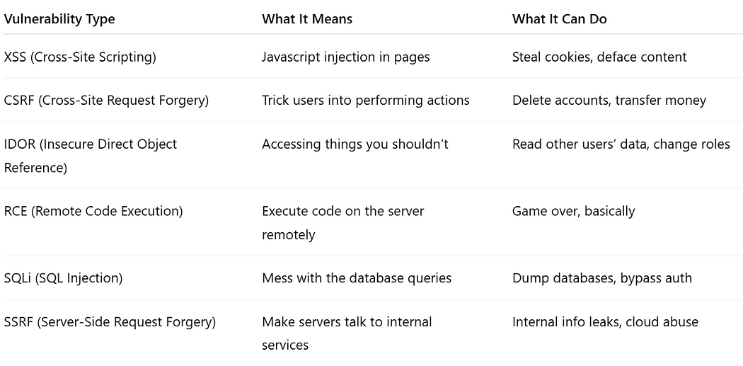

Most Common (Major) Vulnerability Types

You’re not just looking for *any bug,*rather you’re looking for ***impactful***, reproducible flaws that make security teams gasp in horror.

**4. A Day in the Life of a Bug Bounty Hunter**

**Step 1: Choose a Target**

Check HackerOne or Bugcrowd programs. Look for high payout targets or low-hanging fruit. Some go for Google. Others go for “random-site-you’ve-never-heard-of.com” because *less competition*. (Try whatever you think would be impactful but rewarding)

**Step 2: Read the Scope (Like, Actually)**



Average Life. Credit: GIPHY

This is where hunters fail fast. You *must* read the scope. If it says “only www.example.com” and you hack “dev.example.com,” Congratulations, you just wasted 4 hours and will now receive the sacred response: **“Out of scope. Resolved. No bounty.”**

**Step 3: Reconnaissance**

* Subdomain enumeration (Sublist3r, Amass, Assetfinder)
* Passive DNS
* Wayback Machine digging
* Check for weird parameters, legacy endpoints, juicy misconfigurations

This is where 80% of your time goes. Bug bounty is like fishing. Recon is finding the pond. The fish? Those are the bugs.

**Step 4: Bug Hunting**

You’re now in the wild:

* Try parameter fuzzing (Example: *?id=123*-> *?id=../../../etc/passwd*)
* Look for open redirects, race conditions, rate limits
* Test every input like you’re the most annoying user alive
* ***IMP:*** Use the Brains and the Knowledge

**Step 5: Report Writing (Yes, You Have to Write)**

No, “XSS in /search” is not a report. Try this instead:

* Title: Clear and scary
* Summary: What you found, how bad it is
* Steps to reproduce: Screenshots, PoC videos, payloads
* **VERY IMP**: Impact: “This could lead to full account takeover.”

**Step 6: Profit (Or Cry)**

* If **accepted**: You get cash, points, or “*Thanks hacker, here’s a T-shirt.*”
* If **rejected**: You get ghosted or hit with a duplicate report faster than you can say “race condition.”

**5. The Bug Bounty Mindset: Think Outside the Firewall**



Think...? Credit: GIPHY

Bug bounty isn’t just about tool spamming Burp Suite. It’s about:

* **Curiosity:** “What if I send a **GET** instead of **POST**?”
* **Persistence:**You will spend hours for zero results. Often.
* **Reading:**HackerOne disclosures are better than textbooks.
* **Creativity:**Bypasses, edge cases, weird request orders, forgotten endpoints.

**6. What Not to Do?**



Don't Do It? Credit: GIPHY

* Don’t go out of scope.
* Don’t attack users.
* Don’t DDoS anything. Ever.
* Don’t ask “is this a bug?” in triage.
* Don’t post your zero-day on Twitter for clout (unless you want a ban).

**7. Tool Time: Your Bug Hunter Arsenal**

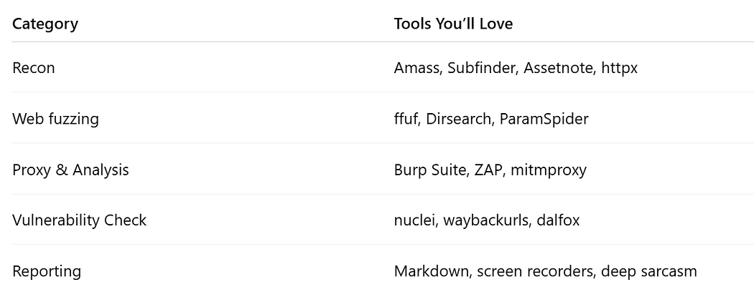

Categories. Credit: GIPHY

**Bonus:** You don’t need ***all***the tools. Just know how to use the ones you pick well.

**8. Top Platforms to Start Bug Hunting**



Photo by [Clemens van Lay](https://unsplash.com/@clemensvanlay?utm_source=medium&utm_medium=referral) on [Unsplash](https://unsplash.com/?utm_source=medium&utm_medium=referral)

* HackerOne
* Bugcrowd
* Synack (invite-only but worth aiming for)
* Intigriti
* YesWeHack
* OpenBugBounty

**9. How to Learn Bug Hunting (Without Frying Your Brain)**

**Practice on:**

* HackTheBox, PortSwigger Labs, Web Security Academy
* bWAPP, DVWA, VulnHub

**Read:**

* HackerOne disclosed reports
* Bug Bounty Hunter Methodology (BBHM)
* “Web Hacking 101” by Peter Yaworski (Personal recommendation)

**Watch:**

* Stök, NahamSec, InsiderPhD, LiveOverflow on YouTube

**Learn:**

* How the web works. HTTP, DNS, cookies, sessions. All of it.

**10. Real Payouts (And Reality Checks)**

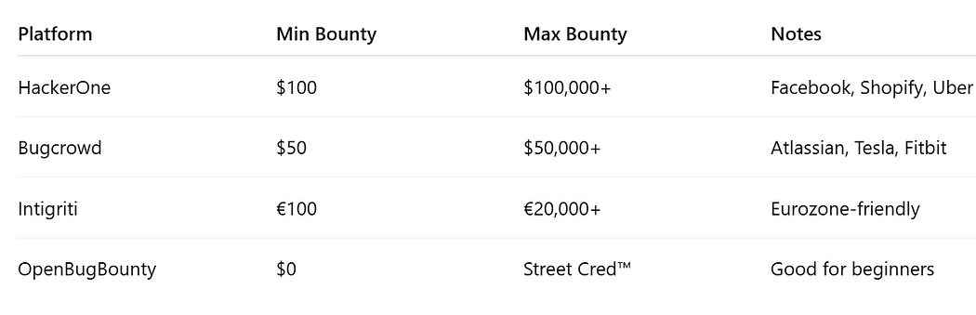

Samples? Credit: Myself

**Is Bug Bounty Right for You?**

* Love breaking things
* Okay with long nights, duplicates, and rejection
* Don’t mind writing reports
* Have decent technical chops
* Want to learn the web by destroying it (ethically)

**If yes**: Then maybe this is good for you.

**TLDR (Bugged but Brief)**

* Bug bounty = legal hacking for cash and karma.
* Requires skill, curiosity, patience, and caffeine.
* You’re not hacking the Matrix. You’re poking web apps and APIs… and occasionally striking gold.
* Stay ethical, stay scoped, and report like a pro.

**Quiz Time**

1. **What’s the first step before testing a target?**

a) Start hacking immediately  
b) Check for scope  
c) Drop all tables  
d) Email Elon Musk

**2. What’s an IDOR?**

a) A typo  
b) Bug that lets you access others’ data  
c) A new crypto token  
d) Internal DNS Outbound Routing

**3. What happens if you go out of scope?**

a) You’re congratulated  
b) Banned, maybe legally pursued  
c) Paid double  
d) Sent to bug bounty jail

*(Answers: 1b, 2b, 3b)*

**Enjoyed the read?**  
Smash the follow button, drop a comment, and share this with someone who still thinks “password” is a good password.